Comments about financial transactions
Our first approach is to understand what money is, a monetary amount, a quantity – a value of something in the form of money that is paid in a contract, related to a debit plan.
We distinguish the processes into:
- Offer
- Evaluation
- Purchase- Sales, in which it is documented if there was a payment or a debit in a context of an agreement about an amount.
All these three processes are completely different and consequently are distinguished.
This model we propose represents the third category, the one of the purchase-sales, which is a kind of compensation/consideration business.
This process consists of two activities of giving and receiving – exchanging goods, as it is defined in terms of a transaction.
Transaction consists of two activities: A transfers to B and B transfers to A – the result which is if the transferred amount is equal to the payment that was agreed or not, defines the kind of the transaction.
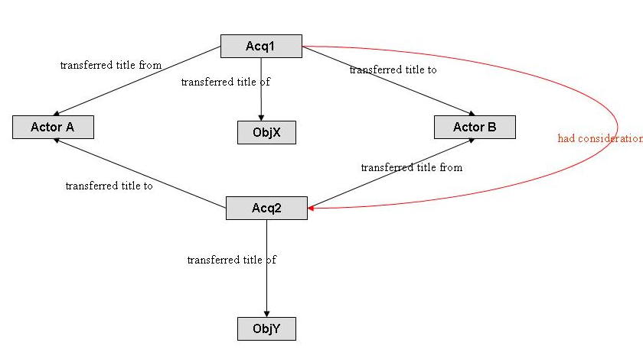
Fig. 1: An example of a transaction

In our effort to understand and represent financial transactions, we made a model of a simple exchange, a model of transaction of material. E8 Acquisition is used in this model (Fig.1) with a more general transaction concept. It mostly implies the ownership of material things.
We examine three types of consideration business transactions:
- complete consideration, in which the analogy of repayment/exchange of goods is 1:n
- multiple consideration, in which the analogy is n:1
- consideration account, in which the analogy is n:m, there is a state of debit and consequently, an account for that. This is the most general case to maintain an open account of debt. In some cases, consideration may also involve third parties.

We propose two models instead of one for representing the process of purchase: in the first model (fig.2) we regard money exchange as a monetary obligation between a creditor and a debitor, which is initialised by a purchase, a kind of acquisition event (E8) and it is ended with the credit that transfers the amount to the creditor’s account or pays in cash. The amount vanishes when it is merged with the receiver’ account. This obligation has time-span (an initial date), a debitor and a creditor and refers to amount of money with currency and a value. This is the simpler case of transaction.

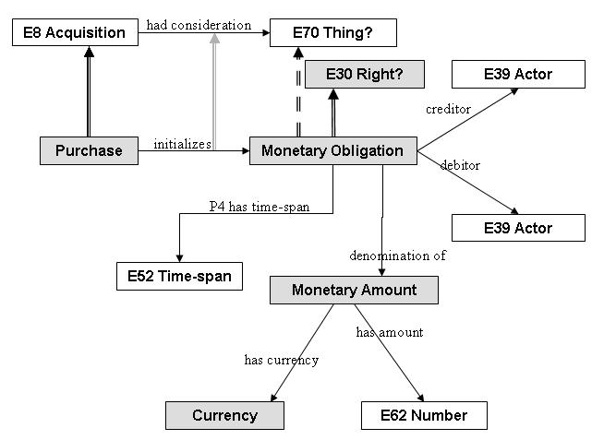
Fig. 2: Monetary Obligation

Issues of this model.

(a) The Monetary Obligation seems to be a E2 Temporal Entity (state)
(b) the denomination is the “initial denomination of”
(c) the Monetary Amount maybe a dimension or a quantity

The other model describes a monetary sale (fig.3,4) as a complete consideration concept, where the exchanged thing is a monetary amount. The purchase, a type of E8 Acquisition, transfers titles of thing/s from one actor to another actor, considering a value thing for that, which is in fact the sale price it had, which is money.
The property “had sales price: E70 Thing” is a shortcut of the more developed path through “Acquisition: had consideration: E70 Thing”, which is also a generalization.
The “thing” that is used as a price, is money, which probably is not a dimension, it cannot be observed, measured; it is a quantity that is liquified and it is used in that form, and it is related to a legal status/contract and it has a specific time-span (a duration).

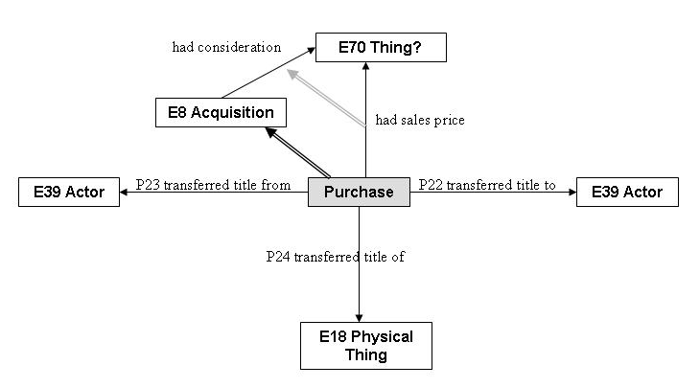
Fig. 3: Purchase

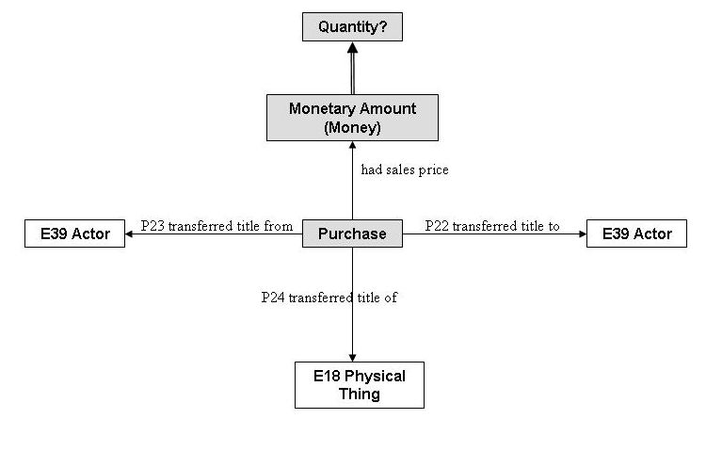
Fig. 4: Purchase
Issues of this model:

(a) Dimension should be changed to quantity ignoring its epistemological dimension. E54 has an empiric nature while “quantity” has a declarative nature. If we accept this model then either the scope note of E54 should be changed or “quantity” should be defined as a more general class of E54. Then we may have the different type of measurements as a specialization of class ”quantity”

There is another model (designed by N.Crofts), which (fig.5) proposes legal objects to be transferred in a purchase activity instead of physical things. In this way, in Croft’s opinion, the rights of ownership can be applied to sums of money. The problem of describing the acquisition of conceptual things arises – is it possible?
Monetary quantity is also represented in this model as E54 Dimension, which has a value and a measurement unit.

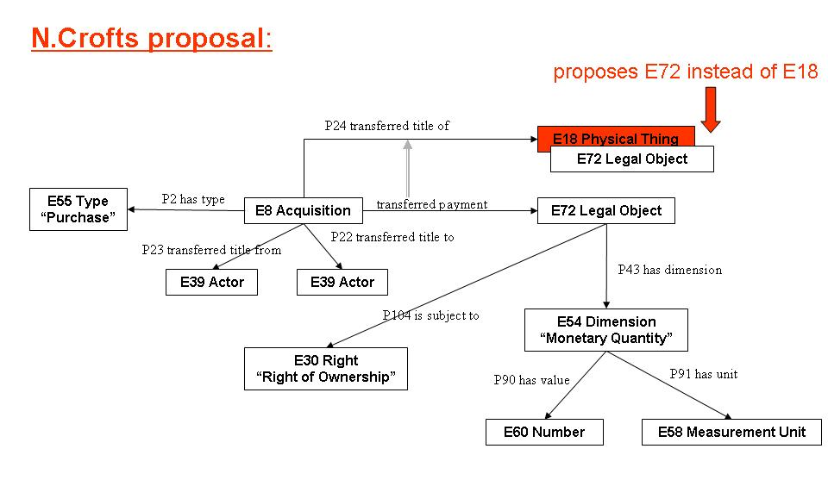
Fig. 5: A different proposal

