30th CIDOC SIG and the 23rd FRBR-CIDOC CRM Harmonization meeting
2 – 4 April, 2014
National Archives, Hague

Participants:
Trond Aalberg (BIBSYS, Norway), Vladimir Alexiev (Ontotext, UK), Peter Andren (Riksarrivet, SE), Kerstin Arnold (Bundesarchiv, APE,NL), Chryssoula Bekiari (ICS-FORTH, GR), Patrick Le Boeuf (National Library of France,FR), Martin Doerr (ICS-FORTH, GR), Wim Van Dongen (Nationaal Archief, NL), Øyvind Eide (Universität Passau, DE), (Maliheh Farrokhnia, HioA, Norway), Gerald de Jong (Delving, NL), Richard Light(UK), Lizzy Longma (Ryksmuseum, NL), Ambjörn Naeve, (KTH,SE), Barry Norton (British Museum, Research Space,, UK ), Mika Nyman (Synapse Computing, FI), Dominic Oldman (British Museum, UK), Chris Oliver (McGill University, CA), Christian Emil Ore (Unviversity of Olso, Norway), Aline Le Provost (ABES , FR), Pat Riva (Bibliothèque at Archives nationales du Québec, CA ), Steve Stead (Paveprime, UK), Thomas Wikman, (Delving B.V, National Archives, SE), Christina Vona(UCL, UK),Maja Žumer (National and University Library, SI),

Wednesday 2/4/2014
1. We started with some discussions about the use of CRM and APEX project
(a) Research Base, an institutional system of British Museum which has adopt the CIDOC CRM
(b) Apex project try to take on board archival institutions. They have systems that export EAD xml and there are organizations that they have developed tools
2. MD presented research queries from Steffen Heinecke. Also it is proposed some of them to uploaded in the site.
3. Then we started a mapping exercise between the CRM and the EAD as used within the Archives Portal Europe for finding aids and holdings guides (May 2013) (attached to the minutes). Some comments are the following:
- It is interesting who has the material (pg. 17). Repository is ignored in CIDOC CRM. In archives it is not the research group that make the publishing but the organization. Also they are not interested about the editor of the publication.
- How the derivation chain is recovered (pg 23).
- They are interested about information provenance
- They distinguish the inventory from holding
- The archival description concerns the level of fonds(pg. 27)
- They are interested who holds the digital archive analog (pg.28)
- They have collection or accumulation activities and possible they have range dates
4. Christian Emil presented the ISAAR (CPF) and a possible mapping to CIDOC CRM based on socialarchive.iath.virginia.edu, Christian Emil will make a proposal about the mappings and also those that they cannot be mapped. If we control the extraction process, we need experts to declare the identification of events . CEO proposes to add relations between historical events. The committee is open to suggestions. If we manage to connect people with more than one events, these should be cross links in events.
5. Mika Nyman presented the conceptual model of Finnish archives
6. Martin Doerr presented the mapping reference model.
7. Pg 28. <unitid encodinganalog="3.1.1">MS-R72</unitid>: We need to have in CRM a collection or accumulation activity. If we describe the production of each individual item, we have too many unkown things.
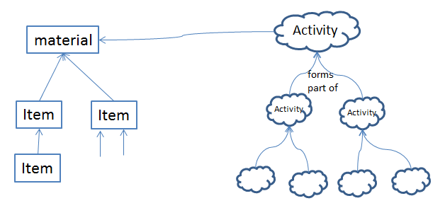
Item creation = identity criteria for activity : (a) it is from the same creator? (b) following the same mandate?
Unity Criteria : (1) same creator (2) continued activity by series of creator (3) type of activity / mandate
If we have an accumulation activity, we should have a range of dates
Collective activity: ??activity has timespan unittable
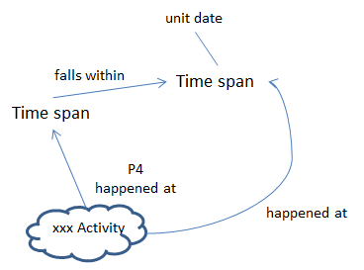
Some notes on above figure are:
a. The unit date tries to address an accumulation activity or the activities that falls within in the accumulated time span
b. the xxx Activity would be superclass of Pursuit or subclass of curation

Thursday 3/4/2014

We started with the presentation of Maliheh Farrokhnia. She presented “A request-based framework for FRBRoo graphical representation: With emphasis on heterogeneous cultural information needs”
Then Lizzy Jongma presented about and sharing images of Rijkmuseum.
Then we discussed about the new site of CRM and we decided to send a URL for the new site to all CRM-SIG members.
Then we started the discussion about CRM issues.

CRM ISSUE 230: co reference statement
Following the discussion made on the CRM-SIG mailing list, we made the figure 1.
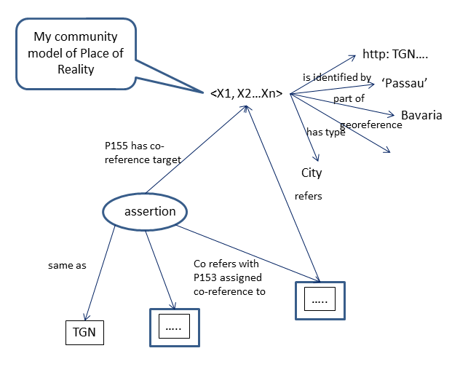
Figure 1 making co reference statements
Then we discussed what qualifies a URI to represent a reality or to refers to something.
We made the following assumptions:
The URI only makes sense in combination with a knowledge base which describe the reality
URI & P155 has co-reference target (is co-reference target of)
(1) P155 points to a local model of reality => unique URI and knowledge of real world object
(2) External URI is used, it is assumed to be known and unique
(3) If (1),(2) hold then P155 and P153 is a valid statement
URI & P153 assigned co-reference to (was regarded to co-refer by)
(4) P153 can be used for external URI? Assumed context of URI to be implicit
Finally we decided
(a) to be a note in the scope note of E91 for external URI
(b) Resolving “same as” within my knowledge base is not E91
(c) MD will try to formulate these things

CRM ISSUE 205
The example:
“The 3D model VAM_A.200-1946_trace_1M.ply (E73) represents Victoria & Albert Museum’s Madonna and child sculpture (visual work) A.200-1946 (E22) mode of representation 3D surface (E55)”
for P138 from 3D CORFORM is accepted.
Steve will improve the scope note of P138

CRM ISSUE 229
If an encounter event encounter a carrier, can be applied to the immaterial which is carried. Also a discussion point was if we observe something by remote sensing, is this action a natural observation process? Stephen Stead and Dominic will review the encounter event.

CRM ISSUE 231
It is decided that the class Encounter event sufficiently covers the request to add a subclass of Discovery or Finding. It is decided the issue to be closed and a new issue about “becoming the Encounter Event part of the CIDOC CRM” to be introduce

CRM ISSUE 191
An issue is posed to investigate that if something is man made, is there a human activity on it without being in conflict with production and existence?
MD will provide arguments for relaxing the range to E18 Physical Thing. The issue remains open.

CRM ISSUE 44
The CRMSci provides a model of State. When CRMSci is accepted, the issue is closed.

CRM ISSUE 195
A new proposal for P134 have been made by MD. The proposal is accepted.
The proposal is
“This property associates two instances of E7 Activity, where the domain is considered as an intentional continuation of the range. A continuation of an activity may happen when the continued activity is still ongoing or after the continued activity has completely ended. The continuing activity may have started already before it decided to continue the other one. Continuation implies a coherence of intentions and outcomes of the involved activities.

CRM ISSUE 214
The examples for P69 by CEO are accepted.

CRM ISSUE 233
MD provided new revised scope note and example for E75 Conceptual Object Appellation. The issue is closed.
Also it is proposed someone to write an issue which specializations of appellation should be removed.

CRM ISSUE 234
It decided that the E93 Snapshot will reduce to one instance of the time span not the space. Also We decided to delete the properties P162 and P163 and maybe we may reconsider about them when we have more evidence. MD will rewrite the scope note of E93.
Also we found an error about Time Span and Temporal Entity. An new issue is to check the cardinalities of P4 has time span without temporal entity.
Then we need the continuity in time (Period). We have to do the following:
(a) to revise the scope note of E52 to express the requirement of continuity in time
(b) then we have to state that a period must be contiguous in time but not in space
(c) P157 the inverse has to do with the reference place. An issue is if it is a reference point (MD will think about this)
(d) P158 needs a complete revision
(e) P4 and P5 is shortcut of
(f) we have to revise the quantification of the space time volume.

Friday 4/4/2014
Patrick Le Bouef presented PRESSoo. Some comments on it, were the following.
(1) The range of YC16 should be changed to E18 Physical Thing.
(2) What is the status of FRBR group opinion?
(3) it is supported by the authority of ISSN. This endorses PRESSoo, since turn to International Library of France for advice. The role of ISSN is to aggregate material.
(4) The crm-sig group decided that PRESSoo is FRBRoo and CIDOC CRM compatible extension.
Then we started to discuss the issues.

FRBR ISSUE 10
We discussed about new class F53 Material Copy and F54 Utilized Information Carrier and the scope notes that MD provided. We designed the following schema.
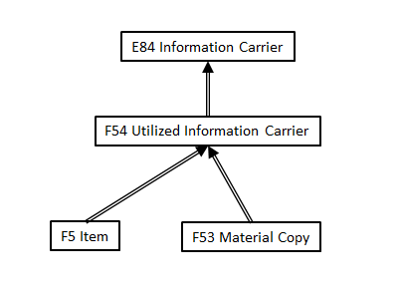
We change the text of E84. MD will elaborate a text about modifications to man-made thing and to physical man-made thing.
Also it is proposed to formulate an issue about how things produce to carry information.

FRBR ISSUE 12
We discussed about F27 Work Conception and F28 Expression Creation. We revised the text provided by PLB and we decided by email PLB will refine the F27 Work conception.
We modified R16 initiated (was initiated by) since we have introduced this notion because we couldn’t down the evidence of the work. We have abackground process of the evolution of the stages. The scope note would make clear that we don’t describe the evolution of the process. Anything that can be automatically interpreted are not explicitly modelled.

FRBR ISSUE 15
It is accepted to change the range of R14 incorporates (is incorporated in). Also the scope not is revised. The issue is closed.

FRBR ISSUE 18
We discussed and revised the scope note of F52 Name Use Activity.

FRBR ISSUE 14
We decided that R3 as it is revised satisfies this issue.

FRBR-CORE / CRM CORE
We discussed about how to define the FRBR – CORE. We formulate the following questins that it should be satisfied by both FRBR –CORE and CRM CORE.
(a) What we expect the audience to be
(b) to follow the FRBR_{ER} profile
(c) The notion of CORE is a sort of application profile for frequent cases, compact enough for understanding the whole complexity easily.
(d) the complexity of understand the hierarchy should be out of the document.
Trond will work on FRBRoo and Dominique will work on CRM

Photographs and animation
Pat will send a revised version of 2.1.7 introduction about photographs.

CRM ISSUE 236 / 161
It presented the classes for the CRM CORE and the rdfs expression of them, following under the scope of CRM family models.
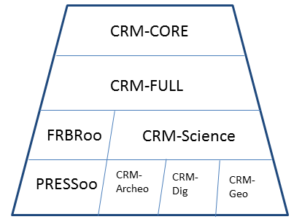
The sig discussed about the proposed extensions and the FRBRoo and decided the following:
(a) consolidation work of FRBR will be reported by Pat
(b) The CRMsci will be presented in the main conference CIDOC 2014 and as tutorial.
(c) The CRMArcheo , produced the European Research Infrastructure Project ARIADNE for archaeology having a proposed a draft extension of CIDOC CRM for complete representation or archaeological excavation records will be under review by the CIDOC Archaeological working group. Also it will be presented as a tutorial in CIDOC 2014 conference.
(d) CRM-SIG approved that the development of CRMSci and its exsention CRMarcheo into CRM compatible ontologies is in its scope. The harmonization of the two models will be a part of the development of version 6 of CIDOC CRM CRM-SIG
(e) the crm – sig aims that CRMSci and CRMarcheo will become models recommended by CIDOC.
(f) Christian Emil will be deputy chair of crm-sig to CIDOC and will inform the board committee group about our activities and it will ask the general assembly to approve that all these fall in the interest to museum documentation.
(g) in the CIDOC 2014 conference, the crm-sig will make a meeting between 3D ICOMOS Cyprus and with board advisor of this Marie Currie Thematic network.
(h) Barry Norton will help about the name spaces
(i) crm-sig decided to apply the approval procedures about PRESS OO.

CRM ISSUES 199 and 219
CEO will elaborate. Also we decided to add to the terminology an explanation about “superproperty of inverse”

CRM ISSUES 223 and 227
We decided to close 223 and to integrate with 227.

CRM ISSUE 235
To be elaborated by MD

CRM ISSUE 238
To be elaborated by CEO

Next meetings

The crm sig decided the forthcoming meetings:
29th of September in Crete, 9th of February Stockholm

